The Dashboard for inputting live data has not been made yet.

Thus, the only way to use the model currently is to input data from Google Trends into an Excel spreadsheet, then uploading the CSV file into the Python code.

1. Install Python packages and dependencies including:

1. Keras
2. Tensorflow (very hard to install – if you need help, email me)
3. Numpy
4. Matplotlib
5. Pandas
6. Sklearn
7. Ipython
8. Jupyter

You can do this by installing Anaconda Continuum Python’s distribution package. (One file to install) at https://www.continuum.io/downloads

2. Load the code provided in Jupyter Notebook

3. Get data from Google Trends in both Spanish and Portuguese and import into a CSV file.

Go to: https://trends.google.com.br/trends/explore?date=2012-02-11%202017-03- 29&geo=BR&q=ultrassom,pequeno,cabe%C3%A7a,trimestre,gr%C3%A1vida

Change the date if you want.

Input data for search terms: (First Portugese)

ultrassom,pequeno,cabeça,trimestre,grávida

criança,mãe,Mamãe,bebê,médico

babycenter,clínica,anormal,Tamanho,circunferência

cérebro,nervo,tumor,sangue,amniótico

fluido,nascermos,gravidez,Fralda,Vômito

nascimento,hospital,incapacidade,Desativado,crescimento

Input data for search terms: (Now Spanish – NEW FILE)

Ultrasonido,pequeña, cabeza, trimestre, embarazada

Niño, madre, mamá, bebé, doctor
Babycenter, clínica, anormal, tamaño, circunferencia

Cerebro, nervio, tumor, sangre, amniotico

Fluido, nacido, embarazo, panal, Vomito

Nacimiento, hospital, discapacidad, discapacidad, crecimiento

*** YOU MUST INPUT WEEKLY DATA → not daily (you can try, but we don’t think

Check the training data format if you are stuck.

** REMEMBER – only numbers in CSV (no dates, no column names).

** ALL COLUMN names MUST be in the SAME order as the search terms we provided. (ie: ultrassom must be first, then crescimento is last column.

4. Simply import your new data like so:

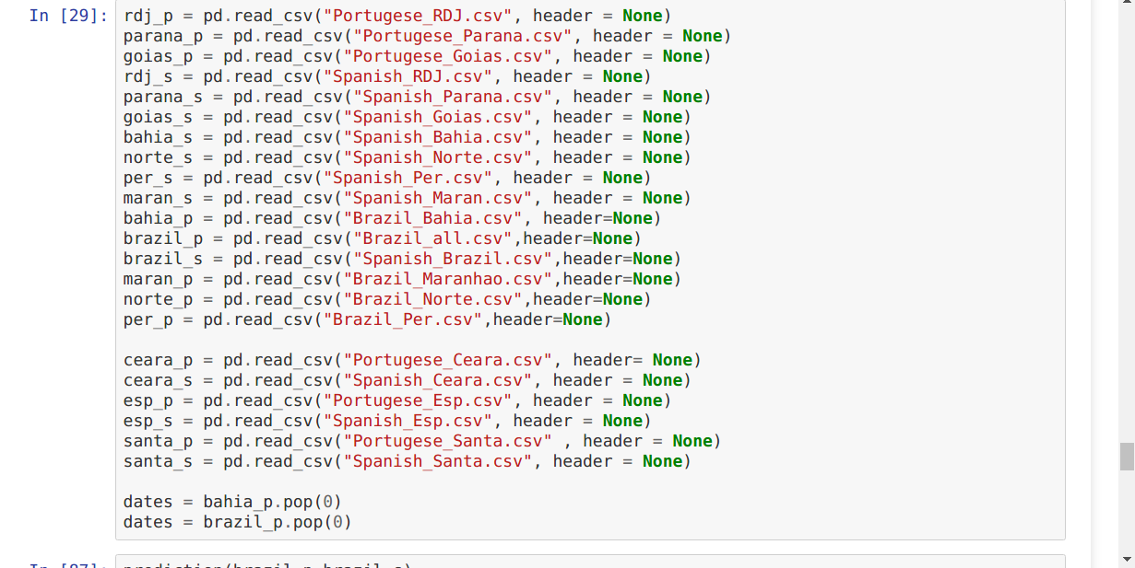

Remember to include both spanish and portugese files

(portugese is NAME_p, spanish is NAME_s)

Place the test data within the cell in Jupyter Notebook (approx 8/10s way down the code).

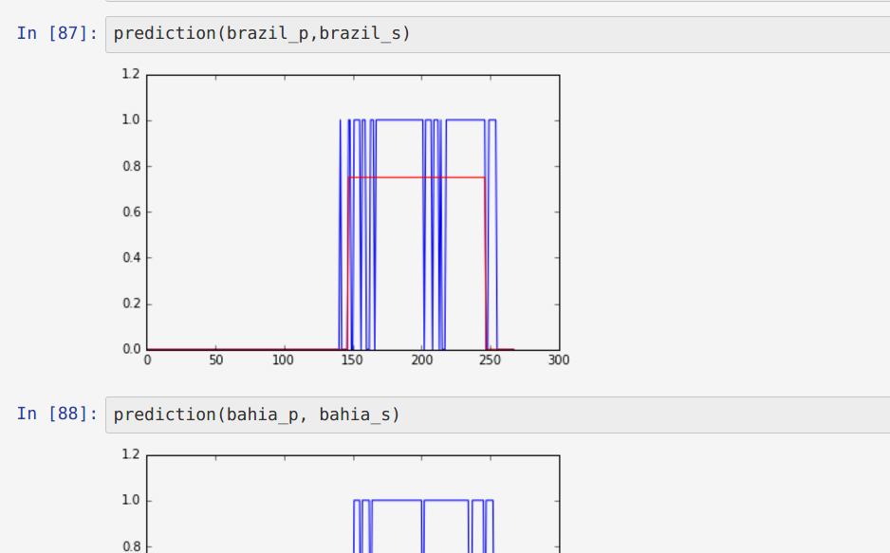
5. If you want to test the model training, go to 6. If not go to 7.
6. Then, execute EACH cell by clicking CTRL + ENTER and keep going down UNTIL you see:

7. If you want to use the pre-trained model for the Neural Network, use the hd5 file provided, and execute within the code:

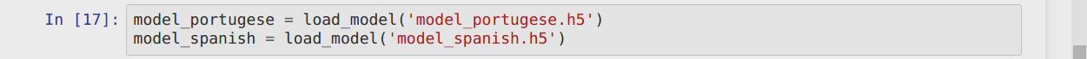

8. Then, type your data into the prediction funtion:

9. The resulting output or graph is the Outbreak Confidence (1 for yes outbreak, 0 for no outbreak)

10. To test the Recurrence Model:

You’ll need to install Julia lang by installing:
1. Atom editor

11. Load the 49.jl script (49 squares tested), and highlight all, and execute.

12. Open the resulting CSV file output, and you can see the no. of S, I and R.

Remember to email me for problems.

